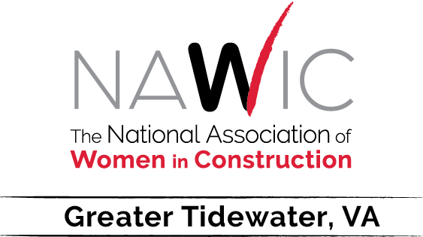

Chapter 137

Meeting Schedule 2022

Updated: January 25, 2022

February 16, 2022 St. George Brewing Co., Hampton, VA
Speaker: Jenny Therrien-Schaffer, Contract/Project Manager
W.M. Jordan Company

March 6-12, 2022 National Women in Construction Week
Events to be Announced

March 23, 2022 Bravo Italian Kitchen, Virginia Beach, VA
Speaker: Sherri Miles, President
Miles Roofing, Inc.

April 20, 2022 St. George Brewing Co., Hampton, VA
Speaker: Terri W. McIntosh, President & CEO
REW Corporation

May 18, 2022 Bravo Italian Kitchen, Virginia Beach, VA
Speaker: Rebecca A. Ferqueron, CPA, CCIFP, Partner
Sullivan Andrews & Taylor

4880-3827-2773, v. 1

